# Introduction

Despite natural gas being used as early 500 BC. By the Chinese for boiling water. It wasn't until 1859 that the first oil well was established by "Colonel" Edwin Drake, for discovering oil. By 19th Century, oil became vital for most industries, such as the Automotive, Aircraft and even to extent of replacing coal fuel in the Ship Industry. Also, advancement in the transportation of the gas through piping, instead of burning the off. This achievement makes remote sites accessible. With the availability of this natural gas, synthetic diesel (syndiesel) can be created. This coupled with other biological source such as ethanol and biodiesel, has tripled the potential reserves of hydrocarbon fuels.

# Process Overview:

A typical oil and gas production process involves production wellheads that feeds into production and test manifolds (i.e. gathering system), and then to the actual process of the Gas Oil Separation Plant (GOSP), which will process the well flow into clean marketable products: oil, natural gas or condensates. A number of other utility systems, which are not part of the actual process are also included. A brief illustration of this process is shown in figure2.1;

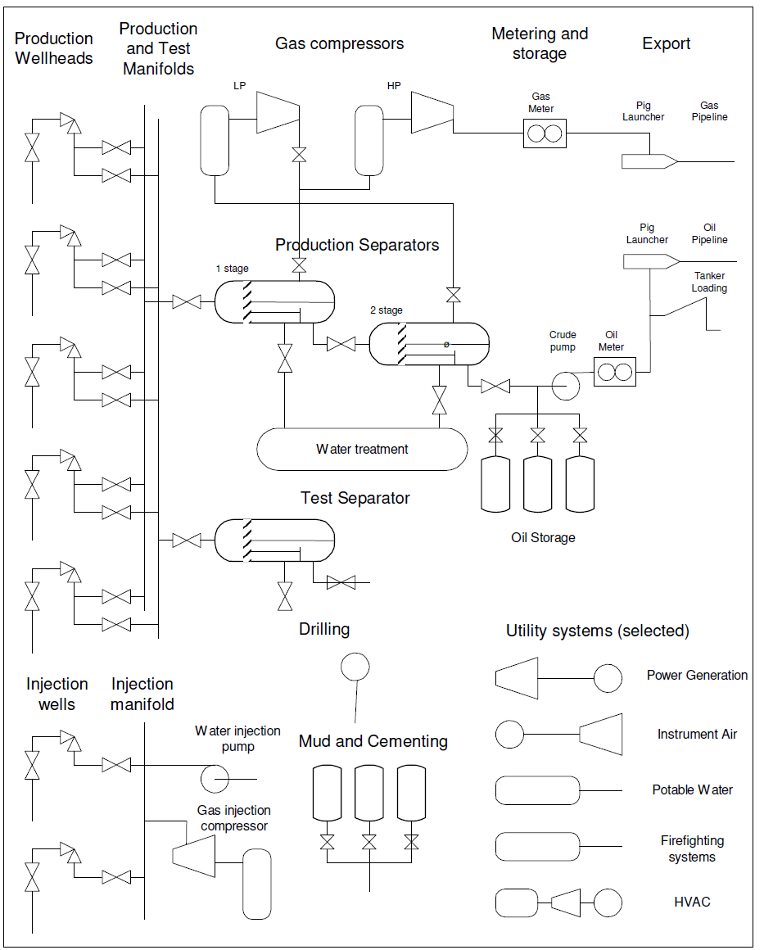

## Production Facilities

|  |  |  |
| --- | --- | --- |
| Types | Sub Types | Features and Description |
| Onshore |  | * Can consist of high capacity wells with thousands of barrels per day, connected to a 1.000.000 barrel a day gas oil separation plant (GOSP). * Product is sent from the plant through pipeline or tankers, from different licences owners. |
| Offshore | Shallow water complex | * Characterised by individual platforms such as Wellhead Platform, Riser Platform, Processing Platform, Accommodations, Platform and Power, Generation Platform, linked by gangway bridges. * Typically found in water depths up to 100 meters.     Figure 2.4 Ekofisk Field Centre by Phillips petroleum |
| Gravity Base. | * Consist of concrete fixed structures that rests on the sea bottom, usually with oil storage cells at its “skirt”. * Typical for 80s and 90s large fields in 100 to 500 water depth.     Figure 2.5 world’s largest GBS platform |
| Compliant towers | * consist of a narrow tower, attached to a foundation on the seafloor, which are flexible to absorb wind and sea pressure. * Used at 500 to 1000 meters water depth. |
| Floating production | * Topside systems are located on a floating structure with dry or subsea wells. Examples of floaters are:   + Floating Production, Storage and Offloading (FPSO); Capable of Water depths 200 to 2000 meters and common with subsea wells.      * + Tension Leg Platform (TLP); this structure is held in a fixed position by tensioned tendons connected to the sea floor by pile-secured templates. And used in a broad water depth range up to about 2000m      * + SPAR; consists of a single tall floating cylinder hull that is tethered to the sea bottom by a series of cables and lines, supporting a fixed deck. And used for water depths from 300 to 3000 meters. |
| Subsea production systems | * This are wells located on the sea floor, while transporting oil and gas through undersea pipeline and riser to a processing facility (surface rig). * They are limited by horizontal distance (Horizontal offsets up to 250 kilometers, though 241 km are currently possible) * Used use at depths of 2,134 meters or more     Figure 2.6 Norsk Hydro ASA |

## Process Sections

The main process consists of the following sections:

|  |  |
| --- | --- |
| Sections | Description/Functions |
| Wellheads (also known as Christmas tree) | * This are either dry or subsea completions, which sits on the top of an oil of gas well, for extraction. * Evaluation of the pressure and temperature of the formation is also included for efficient flow, which is controlled by a choke * They are also used for injection of water or gas, while providing allowance for well workover. |
| Manifolds/gathering | * Consists of a network of gathering pipelines and manifold systems, used for well sets such as the use of individual gathering or multiphase pipelines for dry or subsea completions respectively. * Metering is easier at individual to manifolds than that of multiphase, which requires software to estimate the flow rate of the combination (gas, oil and water and various contaminants). |
| Separation | * Used to separate combination using separators such as;   + Gravity separator, which is a horizontal vessel. And of a 5 minutes retention period to bubble out the gas, with water settled at the bottom and the oil removed from the middle. * For a more controlled separation of volatile components a high and low pressure or any other separators can be used, also avoid sudden pressure drop. |
| Gas compression | * Used mostly to recompress gas from separators, through a centrifugal compressor that is powered by an electric motor or a self-operating compressor turbine using small portion of the natural gas. * Common equipment associated with this process are scrubbers (removing liquid droplets) and heat exchangers, lube oil treatment etc. |
| Metering, storage and export | * Allowance of operators to monitor and manage the natural gas and oil exported from the production installation, Through specialized meters. * This metered volume creates what is known as Custody Transfer Metering. * Pigs (with launchers and receivers) can test pipe thickness, and roundness, check for signs of corrosion, detect minute leaks, and any other defect along the interior of the pipeline. (Pipelines are from 6 to 48 inches in diameter). * Also loading systems, ranging from tanker jetties to sophisticated single point mooring can be found on tankers |

## Utility systems

This provides some utility to the main process safety or residents, such as electricity, water etc.

# Reservoir and Wellheads

Considering the three conventional wells, natural gas and condensate wells does not necessarily need lifting equipment and well treatment, being that natural gas and liquid hydrocarbon mixture are lighter than air respectively, while these equipment installations will be required for oil wells.

## Crude oil and Natural gas

|  |  |
| --- | --- |
|  | Properties |
| Crude Oil | * consists of about 200 or more different organic compounds, mostly hydrocarbons in complex mixture. * The higher the API gravity number the less dense (lighter, thinner) the crude in degrees API which typically range from 7 to 52 corresponding to about 970 kg/m3 to 750 kg/m3 (most fall in the 20 to 45 API gravity range). This API can be used to measure the quality of unadulterated crude oil. * Light crude (i.e., 40-45 degree API) is optimal, molecules becomes shorter or longer for values higher or less than this respectively. * Sulfur elements are removed on regulated crude oil. * The medium carbon atom blend number is desired to be optimal, due to its high output of more octane gasoline and diesel fuel in the cracking refinery. |
| Natural Gas | * Associated gas from oil well in form of free gas or dissolved gas, and non-associated from gas and condensate well are all composed primarily of methane. * Separation of various hydrocarbons and fluids from the pure natural gas, to produce dry natural gas (‘pipeline quality’) are carried out to prevent pipeline transportation restrictions. * The calorific value or wobbe index are measured in kJ/kg. |
| Condensates | * This are natural gas liquids (NGL), which contains associated hydrocarbons of ethane, propane, butane, iso-butane and natural gasoline. * They are used as diluent for heavy crude, energy source for oil refineries or petrochemical plants and serves as raw materials for various other uses. |

### The Reservoir

Oil and gas reservoir are formed as organic material (tiny plants and animals) deposited in earlier geological periods, typically 100 to 200 million years ago or even young reservoir (e.g. 60 million years often has heavy crude, less than 20 API), which are transformed by high temperature and pressure into hydrocarbons being trapped between a bearing structure of porous rock (e.g. sandstone or washed out limestone) and a non-porous layer (such as salt, shale, chalk or mud rock). This also forms heavy oil reservoirs or tar pools if volatile compounds have evaporated from shallow sandy formations through strong uplift and erosion or cracking of rock above, which allows the hydrocarbons to leak out.

The challenge faced in reservoir drilling is to maximize it utilization through proper planning because of the complexity of the folds and several layers of reservoirs. Hence seismic data and advanced visualization 3D models are used to plan the extraction such as advanced Enhanced Oil Recovery (EOR) that allows up to 70% utilization.



### Exploration and Drilling

The main components of the drilling rig are the Derrick, Floor, Drawworks, Drive and Mud Handling with hydraulic or electric for control and power the top drive or semi-automated pipe that gives pressure and rotational torque to the drill string hung from the derrick crown. The whole assembly is controlled by the drawworks. The Drill String is assembled from pipe segments about 30 meters (100 feet) long normally with conical bits, inside threads at one end and outside at the other. Examples of conical bits are, roller cones with inserts (on the left); other bits are PDC (polycrystalline diamond compact, on the right) and Diamond Impregnated. The drill string weight increases about 500 metric tons or more for a 3000 meter deep well, hence typical values of 50kN force are used on the bit and a torque of 1-1.5 kNm at 40-80 RPM for an 8 inch cone bit.



|  |  |
| --- | --- |
| Vertical Drilling | They are drilled vertically down, with little or no change in angle point where the bit enters the earth |
| Directional Drilling | This are intentional deviation using drill motor driven by mud pressure mounted directly on the cone (Mud Motor, Turbo Drill, and Dyna-Drill), whipstocks (i.e. a steel casing that will bend between the drill pipe and cone, or other deflecting rods). |
| Horizontal Drilling | A well which has sections more than 80 degrees from the vertical, usually with large horizontal offsets to reach different parts of the structure and to achieve higher production. It also uses whipstocks for drilling. |

The well is characterized by pressure and temperature generally increasing as depth increases, so that deep wells can have more than 200 deg C temperature and 90 MPa pressure (900 times atmospheric pressure), which is equivalent to the hydrostatic pressure set its distance to the surface. This well is at depth of more than 6000 meters, with oil and gas typically formed at 3000-4000 meters depth. The crude oil has a specific weight of 790 to 970 kg per cubic meter. For a 3000 meter deep well with 30 MPa downhole pressure and normal crude oil at 850 kg/m3, the wellhead static pressure would only be around 4,5 MPa, which reduces further during production due to resistance to flow in the reservoir and well.

The mud (either Oil Base, Water Base or Synthetic) that enters through the drill pipe serves several purposes, such as:

* Bring rock shales (fragments of rock) up to the surface
* Clean and Cool the cone
* Lubricate the drill pipe string and Cone
* Fibrous particles attach to the well surface to bind solids
* Mud weight should balance the downhole pressure to avoid leakage of gas and oil. Often, the well will drill though smaller pockets of hydrocarbons which may cause “a blow out” if the mud weight cannot balance the pressure. This can also be prevented by installing capable safety valve.
* A special high-density mud called Kill Fluid is used to shut down a well for workover.

### The Well

After drilling the well should be completed with the following steps; installing the well casing, completing the well, installing the wellhead, and installing lifting equipment or treating the formation.

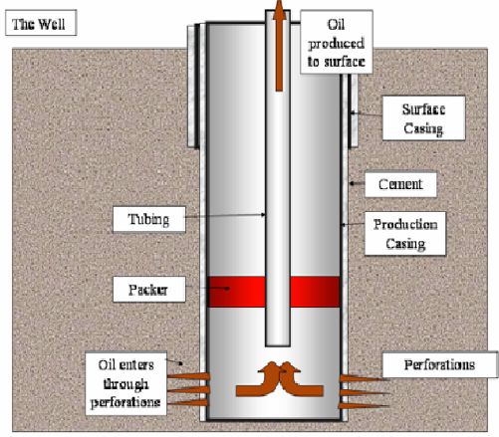

|  |  |  |
| --- | --- | --- |
| Steps | Types | Description |
| Well Casing  (A packer is used between  casing and tubing at the bottom of the well) | Conductor casing | Usually no more than 6.1 to 15.24 meters long, installed before main drilling to prevent the top of the well from caving in. |
| Surface casing | Can be anywhere from 100 to 400 meters long, and fits inside the conductor casing with its smaller diameter. It mainly serves to protect fresh water deposits near the surface of the well from being contaminated by leaking hydrocarbons or salt water from deeper underground. |
| Intermediate casing | Usually the longest section of casing found in a well, with main purpose of minimizing the hazards that come along with subsurface formations that may affect the well. |
| Production casing ('oil string' or 'long string') | Last installed and deepest section of casing in a well, which provides a conduit from the surface of the well to the petroleum producing formation. Its size is dependents on the lifting equipment to be used, the number of completions required and the possibility of deepening the well at a later time. |
| Completion  (consist of deciding on the characteristics of the intake portion of the well in the targeted hydrocarbon  formation) | Open hole completions | They are the most basic type and are only used in very competent formations, which are unlikely to cave in, and consists of simply running the casing directly down into the formation, leaving the end of the piping open with no protective filter. |
| Conventional perforated completions | Consists of production casing being run through the formation. The sides of this casing are perforated (either with older 'bullet perforators’ or newer preferred 'jet perforating’), with tiny holes along the sides facing the formation, which allows for the flow of hydrocarbons into the well hole, while providing suitable support and protection for the well hole. |
| Sand exclusion completions | Used in areas of large amount of loose sand, to prevent sand from entering the well through a screening or filtering systems in open hole and perforated completions. |
| Permanent completions | The assembled completion and wellhead with casing, cementing, perforating and other completion are installed only once using small diameter tools to ensure the permanent nature of the completion. This are significantly cost efficient compared to other types. |
| Multiple zone completion | It is a practice of completing a well such that hydrocarbons from two or more formations may be produced simultaneously, without mixing with each other. A hard rubber 'packing' instruments can be used to maintain different completions separation. |
| Drainhole completions | Consists of drilling out horizontally into the formation from a  vertical well, to provide a 'drain' for the hydrocarbons to run down into the well. It is commonly associated with oil wells. |

### Wellhead

The wellhead consists of various equipment (such as, the casing head, the tubing head, and the 'Christmas tree' mounted at the opening of the well to regulate and monitor the extraction of hydrocarbons from the underground formation, which also prevents leaking of oil or natural gas out of the well, and blowouts due to high pressure formations of up to 140 MPa (1400 Bar). A typical Christmas tree (either vertical or horizontal tree) are composed of a master gate valve, a pressure gauge, a wing valve, a swab valve, a choke and may also have a number of check valves.

|  |  |
| --- | --- |
| Devices | Functions |
| Casing Head and casing  Hangers. | The valve fitted to give access to the casing can be used to determine leaks in casing, tubing or the packer, and will also be used for lift gas injection into the casing. |
| The tubing hanger (donut) | Used to position the tubing correctly in the  Well with sealing will alow the Christmas tree removal with pressure in the casing. |
| Master gate valve | Used to control flow, and must be capable of holding the full pressure of the well. |
| The pressure gauge | Used to monitor the well flow pressure. |
| The wing valve | Used so that the tubing pressure can be  easily read. |
| The swab valve | used to gain access to the well for wireline operations, intervention and other workovers. |
| The variable flow choke valve | This large needle valve is calibrated opening, which are adjustable in 1/64 inch increments (called beans). High-quality steel is used in order to withstand the high-speed flow of abrasive materials that pass through the choke, usually for many years, with little damage except to the dart or seat. |

Subsea wells are much same as the dry completion wells, except for its template which allows the wells to be drilled and serviced remotely from the surface, and protects from damage e.g. from trawlers. This control is done through an umbilical provided power by hydraulic power unit (HPU) from the surface. The umbilical is a composite cable containing tension wires, hydraulic pipes, electrical power and control and communication signals.



wellheads with opposite flow direction to production well are referred to as Injection wells. This are drilled to inject gas or water into the reservoir, which are to maintain the overall and hydrostatic reservoir pressure and force the oil toward the production wells. When injected water reaches the production well, this is called injected water break through. Special logging instruments, often based on radioactive isotopes is added to injection water, that are used to detect breakthrough.

### Artificial Lift

Larger wells are equipped with artificial lift to increase production even at much higher pressures. Some artificial lift methods are:

|  |  |
| --- | --- |
| Methods | Features |
| Sucker Rod Pumps (Donkey  pumps) | * used in land-based operations. * The motor speed and torque is controlled for efficiency and minimal wear with a Pump off Controller (PoC). * Its use is limited to shallow reservoirs down to a few hundred meters, and flows up to about 40 liters (10 gal) per stroke. |
| Downhole Pumps | * The whole pumping mechanism including the Electrical Submerged Pump (ESP), are inserted into the well. * The assemble consist of a long narrow motor and a multi-phase pump, such as a PCP (progressive cavity pump) or centrifugal pump, which is hung by an electrical cable with tension members down the tubing. * Installations down to 3.7 km with power up to 750 kW have been installed. At these depths and power ratings in use with Medium Voltage drives (up to 5kV). * Its efficiency is sensitive to GOR (Gas Oil Ratio), where gas over 10% dramatically lowers its efficiency. |
| Gas Lift | * This is archived by injecting gas between casing and tubing into the oil, which lowers its specific gravity to start the well flow. Also, a release valve on a gas lift mandrel is inserted in the tubing above the packer to improve lifting and start up. |
| Plunger Lift | * This is used in well blockage caused by downhole collection of liquids. * A cycle starts when the plunger falls into the well with its valve open leaving Gas, condensate and oil to pass through, until the pluger reaches bottom, where the valve is closed to collect oil, condensate or water on top while accumulating gas pressure under, that pushes the plunger upwards to the plunger catcher. The liquid on top the plunger is then discharge to complete the cycle. |

### Well workover, intervention and stimulation

Well workover is the process of performing major maintenance on an oil or gas well. This might include replacement of the tubing, cleanup or new completions, new perforation and various other maintenance works such as installation of gas lift mandrels, new packing etc. Flexible coiled tubing is much efficient than rigid pipe segments, for workover operations.

Some common terminologies associated with workover are;

well intervention – Is well maintenance without killing the well to performing full workover.

wireline operations – Are operations performed by lowering instruments or tools on a wire into a well.

Reservoir stimulation – are work on the reservoir such as chemical injection, acid treatment, heating etc.

|  |  |
| --- | --- |
| Reservoir Stimulation Operations | Functions |
| Acids | such as HCL (Hydrochloric Acid) are used to open up calcareous reservoirs and to treat accumulation of calcium carbonates in the reservoir  structure around the well. |
| Hydraulic fracturing | This involves a specially blended liquid pumped down a well and into a formation under pressure high enough to cause the formation to crack open, to form fractures for the oil to flow into the well bore. |
| Explosive fracturing | Involves detonation of explosives to form fracture in the formation. |
| Damage removal | This refers to other forms of removing formation damage, such as flushing out of drill fluids. |

### Unconventional sources of oil and gas

Unconventional sources include very heavy crudes, oil sands, oil shale, gas and synthetic crude from coal, coal bed methane and biofuels. These are described in the table below:

|  |  |
| --- | --- |
| Sources | Description |
| Extra Heavy Crude | Commonly found in non-temperate regions, with API of about 15 or lower. Hence steam injection must be used to stimulate flow, the crude must be mixed with a diluent (often LPGs) for ease of pipeline flow. They are also upgraded in a processing plant to make lighter SynCrude (with API ranging 26-30) of high value fuel yields. |
| Tar sands | This can be processed using hot water to separate the bitumen from sand and clay. And then further processed the same way as for extra heavy crude, which contains about 70% oil. Note that wo tons of tar sand will yield one barrel of oil. |
| Oil Shale | Shale oil and combustible gas can be extracted using destructive distillation from fine-grained sedimentary rocks, that contains relatively large amounts of organic matter. This extraction cost is currently around 25-30 USD per barrel. |
| Coal, Coal Gasification and Liquefaction | Unlike oil shale, coal has lower atomic Hydrogen to Carbon ratio. It also has an organic to inorganic matter ratio of more than 4,75 to 5. Coal gasification will transform coal into e.g. methane. And Liquefaction such as the Fischer-Tropsch process will turn methane into liquid hydrocarbons (typically of the form CnH2n+2 ). |
| Methane Hydrates | These formations are made up of a lattice of frozen water, which forms a sort of cage around molecules of methane. Associated with Arctic regions to cover an estimation at anywhere from 180 to over 5800 trillion scm. This is However, an ongoing research. |
| Biofuels | Ethanol is produced from distilled alcohol of fermented sugars and/or starch (e.g. wood or grain). Also, biodiesel is made through transesterification whereby the glycerin is separated from fat or vegetable oil. The process leaves behind two products, which are methyl esters (the chemical name for biodiesel) and glycerin. This biodiesel is simple to use, biodegradable, nontoxic, and essentially free of sulfur and aromatics. |
| Hydrogen | Hydrogen is clean burning, and can be produced either from hydrocarbons (natural gas, ethanol etc.) or water by electrolysis. It can also serve as energy  transport medium in place of bulky batteries for renewable energy source supply chain. |

# The Oil and Gas Process

This is process equipment that takes the product from the wellhead manifolds and delivers stabilized marketable products, in the form of Crude Oil, Condensate or Gas. Included to this equipment are components to clean waste products such as produced water and test its products.

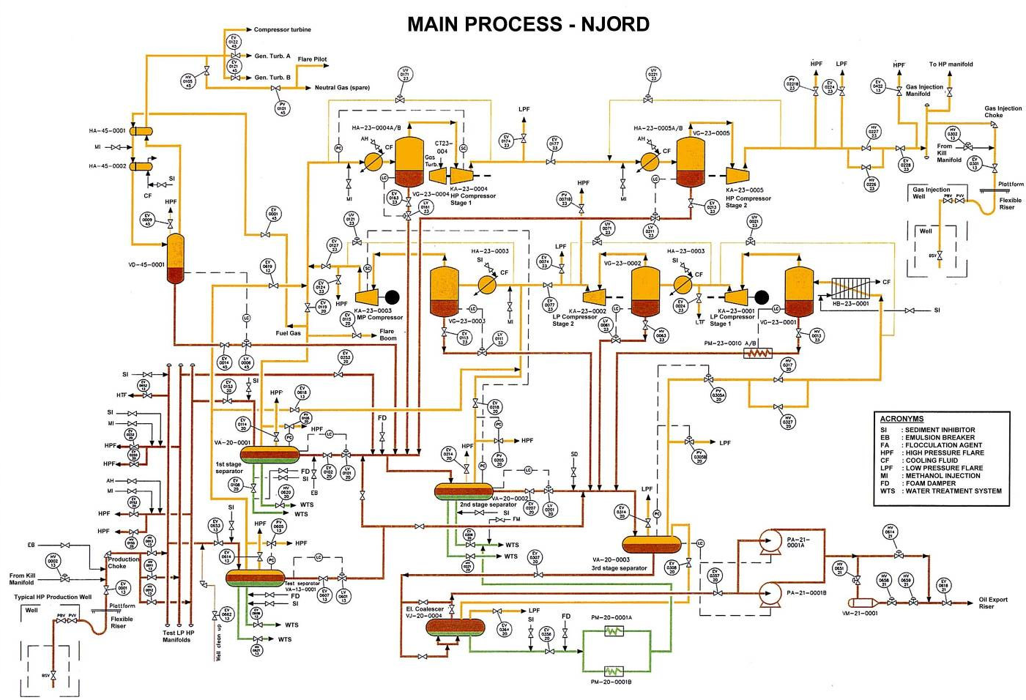

|  |  |  |
| --- | --- | --- |
| Process | Equipment | Description |
| Manifolds and Gathering | Pipelines, and Risers | * A production riser (offshore) or gathering line (onshore) brings the well flow into the manifolds, and usually contains several check valves. * Due to long distance pipeline, slugging can be manually controlled by adjusting the choke, or with automatic slug controls. Also, areas of heavy condensate formation in the pipe are prevented by injecting ethylene glycol |
| Production, test and injection manifolds | * As the name suggest, these manifolds will consist of the process train plus additional manifolds for test, Low Pressure, High Pressure and balancing purpose, and chokes set to reduce the wellhead flow and pressure to the desired HP and LP pressures respectively. |
| Separation | Test Separators and Well test | * Used to separate the well flow from one or more wells for analysis and detailed flow measurement such as flow rates, undesirable behavior and hydrocarbon composition. |
| Production separators | * The pressure is often reduced in several stages to allow controlled separation of volatile components, hence preventing flash vaporization, that leads to instabilities and safety hazards. * First stage separator operates at about 3-5 MPa (30-50 times atmospheric pressure) with temperature often at the range of 100-150 degrees C (for onshore). * The major parts of a typical gravity separator is shown below; |
| Second stage separator | * Similar to the first stage HP separator, in addition to the first stage output, will also receive production from wells connected to the Low-Pressure manifold. * Hence the operating pressure is now around 1 MPa (10 atmospheres) and temperature below 100 degrees C, with water content will be reduced to below 2%. * Reheating could be provided between the first and second stage to facilitate the separation. |
| Third stage separator  (a two-phase separator, also called a flash-drum) | * The pressure is now reduced to about the atmospheric pressure (100 kPa) to boil out the last heavy gas components. * It is best practice to provide heat exchanger to rise the temperature of the production, if the inertial temperature is low. |
| Coalescer | * This contains electrodes that creates electric field to break surface bonds between conductive water and isolating oil in an oil water emulsion. Hence removing and reducing water content below 0.1%. * Its steel field plates (either covered with dielectric material) should generate enough intensity owing the critical field strength in oil that is in the range 0.2 to 2 kV/cm. |
| Electrostatic Desalter | * This will be placed after the first or second stage separator depending on Gas Oil Ratio (GOR), to remove unacceptable amounts of salts (i.e. Sodium, Calcium or Magnesium chlorides) |
| Water treatment | * The environmental regulations limit the amount of oil/water emulsion and bounded sand, found in the water cut from an installation into the sea. * Hence the water is treated first in the sand cyclone (removes sand), then to the hydro cyclone (centrifugally removes oil) and then to the water de-gassing drum (removes gas), the water can now be discharged to the sea, where bacteria can natural break down little left overs. |
| Gas treatment and Compression | Heat exchangers | * For the incoming gas to be effectively compressed, its temperature must be lowered by a heat exchanger. This removed heat are used to reheat oil in the oil train. |
| Scrubbers and reboilers | * Used to remove liquid droplets and hydrocarbons, through dehydration by absorption of this particles in Tri Ethylene Glycol (TEG). * The liquid and hydrocarbons are separated from glycol by boiling (about 130-180 °C) and distillation respectively. |
| Compressor, anti-surge and performance | * Pending on the requirement of operating power, speed, pressure and volume for the gas compression, different types of compressor are available, such as Reciprocating, Screw, Centrifugal (for larger oil and gas installations), Axial blade and fin type compressors. * The objective of the compressor performance control is to keep the operating point close to the optimal setpoint without violating the constraints, through control outputs, such as the speed setting. * The anti-surge control will protect the compressor from going into surge by operating the surge control valve, that allows gas to recirculate. * The main operating parameters for a compressor is the flow and pressure differential. * The final function around the compressor itself is lube and seal oil handling. |
| Gas Treatment | * Unwanted components such as hydrogen sulfide and carbon dioxide are removed through a process called sweetening, which methods are through absorption processes (PSA, TSA and iron sponge), cryogenic processes or hybrid combinations, such as cryogenic and membranes. * Gas calibration are also included to adjust its specific calorific value (BTU per scf or MJ per scm) by adding an inert gas, such as nitrogen. |
| Oil and Gas Storage, Metering and Export | Fiscal Metering | * liquid hydrocarbon (oil and condensate) metering system will first have an analyzer instruments and a pressure/temperature compensation included. * Types of meters used could range from turbine, positive displacement and coriolis massflow meters, at multiple split runs. The calibration of these meters is done accurately through prover loop, using industry standard formulas of API MPMS and ISO 5024. * Gas metering is similar, but instead uses analyzers to measure hydrocarbon content and energy value (MJ/scm or BTU, Kcal/scf) as well as pressure and temperature. The meters are normally orifice meters or ultrasonic meters, using standard formulas (such as AGA 3 and ISO 5024/5167) to calculate normalized flow. |
| Storage | * fixed roof tanks are used for crude, floating roof for condensate are used for onshore, while offshore uses storage tanker or cells on floaters for storage, that can consist of 10-100 tanks (tankfarm) of varying volume for a total capacity typically in the area of 1 - 50 million barrels. * A tankfarm management system logs and consolidate the operations |
| Marine Loading | * This Consist of one or more loading arms / jetties, pumps, valves and a metering system. * Tanker's ballast system operates the different valves and monitor the tanks on board the ship. |
| Pipeline terminal | This includes termination systems for the pipeline. At least a pig  launcher and receiver will be included, to allow insertion of a pipeline pigging, a device that is used to clean or inspect the pipeline on the inside. |

# Utility systems

This is various systems that provides utilities or support the main process.

## Control and Safety Systems

### Process Control

A process control system is used to monitor data and control equipment on the plant.

Some advanced control and optimization functions are:

* Well control may include automatic startup and shutdown of a well and/or a set of wells. Applications can include optimization and stabilization of artificial lift such as Pump off control and Gas lift Optimization.
* Flow assurance serves to make sure that the flow from wells, in pipelines and risers are stable and maximized under varying pressure, flow and temperatures. Unstable flow can result in slug formation, hydrates etc.
* Optimization of various processes to increase capacity or reduce energy costs.
* Pipeline Management modeling, leak detection and pig tracking
* Support for Remote Operations, where facility data is available to company specialists located at a central support center.
* Support for remote operation where the entire facility is unmanned or without local operators full or part time, and is operated from a remote location.

### Emergency Shutdown and Process Shutdown

The Emergency Shutdown (ESD) and Process Shutdown (PSD) systems will take action when the process goes into a malfunction or dangerous state. For this purpose, the system maintains four sets of limits for a process value, LowLow (LL), Low (L), High (H) and HighHigh (HH). Events are classified on a scale, e.-g. 1 to 5 plus and Abandon Platform level. And the general system requirements are set by official laws and regulations and industry standards such as IEC 61508/61511.

### Control and Safety configuration

The configuration is usually illustrated in process Piping and Instrumentation Diagrams (P&ID) format.

### Fire and Gas Systems

This protection utility uses the following devices;

Fire detection:

* Gas detection: Combustible and Toxic gas, Electro catalytic or optical (IR) detector.
* Flame detection: Ultraviolet (UV) or Infra-Red (IR) optical detectors
* Fire detection: Heat and Ionic smoke detectors
* Manual pushbuttons

Firefighting, protection:

* Gas based fire-fighting such as CO2
* Foam based fire-fighting
* Water based fire-fighting: Sprinklers, Mist (Water spray) and deluge
* Protection: Interface to emergency shutdown and HVAC fire dampers.
* Warning and escape: PA systems, beacons/lights, fire door and damper release

### Telemetry / SCADA

SCADA (Supervisory Control and Data Acquisition) is normally associated with telemetry (low bandwidth) and wide area communications (such as optical fibers and broadband internet.), for data gathering and control over large production sites, pipelines, or corporate data from multiple facilities, and SCADA has unique data architecture unlike a basic control system.

### Condition Monitoring and Maintenance Support

Condition monitoring encompasses both structural monitoring and condition monitoring for process equipment such as valves and rotating machinery. The maintenance support functionality will plan maintenance based on input from condition monitoring systems and a periodic maintenance plant.

### Production Information Management Systems (PIMS)

This provides information about the operation and production of the facility. For Oil and Gas, PIMS functionality includes:

* Oil & Gas Production Reporting.
* Safety Management
* Maintenance
* Operator Support
* Overall systems integration and external
* Historical data including post failure “flight recorder” data, and can be used for various other applications.

### Training Simulators

This are used to provide realistic operator training in a realistic plant training environment with real time feedback.

## Power generation and distribution

The power generation system on a large facility is usually several gas turbines diving electric generators, 20-40 MW each. If exhaust heat is not needed in the main process, it can be used to drive exhaust steam turbines (so called dual cycle) for additional efficiency. A sample distribution format is shown below;



A power management system is used for control of electrical switchgear and equipment to optimize electricity by preventing major disturbances & plant outages (blackouts). large variable speed drives are commonly used to drive Large rotating equipment and the generators.

## Flare and Atmospheric Ventilation

The flare subsystem includes Flare, atmospheric ventilation and blow down, of which the purpose of the Flare and Vent Systems is to provide safe discharge and disposal of gases and liquids. To avoid the pilot flame, an ignition system is used to ensure safe ignition (such as ‘ballistic ignition’ system) even when large volumes are discharged.

## Instrument air

Large volume of compressed air is required for the control of pneumatic valves and actuators, tools and purging of cabinets. It is produced by electrically driven screw compressors and further treated to be free of particles, oil and water.

## HVAC

The heat, ventilation and air conditioning system (HVAC) feeds conditioned air to the equipment rooms, accommodations etc. Some HVAC subsystems include:

* Cool: Cooling Medium, Refrigeration System, Freezing System.
* Heat: Heat medium system, Hot Oil System.

Another function of this system is to provide air to equipment rooms that are safe by positive pressure. This prevents potential influx of explosive gases in case of a leak.

## Water Systems

### Potable Water

For smaller installations, the potable water can be transported by supply vessels or tank trucks. While for larger facilities, potable water is provided on site by desalination of seawater though distillation or reverse osmosis.

### Seawater

Seawater is used extensively for cooling purposes. And can be used for reservoir water injection, In which case a deaerator is used to reduce oxygen in the water before injection.

### Ballast Water

This ballast systems are found on drilling rigs, floating production ships and rigs as well as TLP (tension leg platforms), in order to keep them level and at a certain depth under varying conditions, such as mode of operation (stationary drilling, movement), climatic conditions (elevate rig during storms), amount of produce in storage tanks, and to adjust loading on TLP tension members.

## Chemicals and Additives

The most common chemical s and their uses are:

|  |  |
| --- | --- |
| Chemicals | Uses |
| Scale inhibitor | Scale or sediment inhibitor is added on wellheads and production equipment to prevent the clogged-up contaminants such as salts, chalk, and traces of radioactive materials from separating out. |
| Emulsion breaker | An emulsion breaker is added to prevent formation of, and break down of the suspended emulsion layer by causing the droplets to merge and grow. |
| Antifoam | An antifoam agent is introduced upstream of the separator to prevent or break down foam formation, by reducing liquid surface tension. |
| Polyelectrolyte | Polyelectrolyte is added before the hydrocyclones and causes oil droplets to merge, and reduces emissions to reach 40 ppm or less. |
| Methanol (MEG) | Methanol or Mono Ethylene Glycol (MEG) is injected in flowlines to prevent Hydrate formation and prevent corrosion. A Hydrate prediction model software can be used to determine when there is a risk for hydrate formation and to reduce methanol injection or delay depressurization. |
| TEG | Tri Ethylene Glycol (TEG) is used to dry gas. |
| Hypochlorite | Hypochlorite is added to seawater to prevent growth of algae and bacteria e.g. in seawater heat exchangers. |
| Biocides | Biocides are also preventive chemicals that are added to prevent microbiological activity in oil production systems such as bacteria, fungus or algae growth. |
| Corrosion Inhibitor | Are used to protect export pipelines and storage tanks from corrosion (caused by oil) by forming a thin film on the metal surface. |
| Drag Reducers | Drag-reducing polymers suppress the formation of turbulent bursts in the buffer region, and archiving a decrease in the frictional pressure drop in the pipeline by  as much as 70%. Hence improves flow in pipelines. |

## Telecom

This system consists of variety of subsystems for human and computer wired and wireless communications, monitoring, observation and entertainment.